**WORKSHOP ON PCB**

**1. SIMULATION OF LED ON/OFF USING SWITCH**

**CIRCUIT OVERVEIW:**

**LED ON/OFF USING SWITCH:**

* When the switch is pressed, it changes the input signal, which the microcontroller reads. Based on this input, the microcontroller sets a digital output to control the LED, turning it on or off accordingly.

**COMPONENTS:**

* LED:

- A semiconductor light source that emits light when current flows through it. The anode (+) connects to the positive voltage, and the cathode (-) to the ground.

* 220-ohm resistor:

- Limits current to the LED to prevent it from burning out. Connect in series with the LED.

* Push button switch:

- A momentary switch that connects or disconnects the circuit when pressed. It has two states: pressed (closed circuit) and released (open circuit).

* Power source:

- Provides the necessary voltage to the circuit, such as a 9V battery or a DC power supply. Ensure it matches the requirements of the LED and switch.

* Breadboard:

- A reusable platform for prototyping electronic circuits without soldering. It allows easy connections between components using jumper wires.

* Jumper wires:

- Flexible wires used to make connections between components on the breadboard. They come in various lengths and colors for easy circuit assembly.

**DIAGRAMS:**

* **Circuit schematic in Tinkercad:**

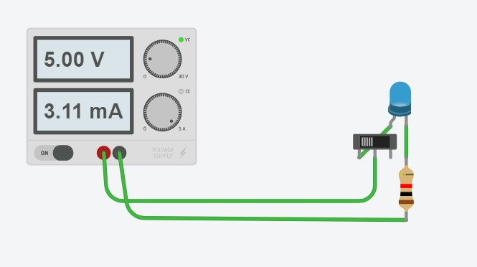

**IN EASYEDA**

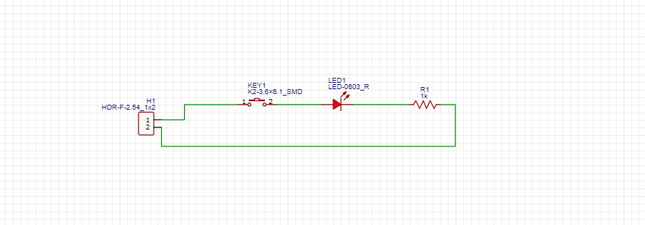

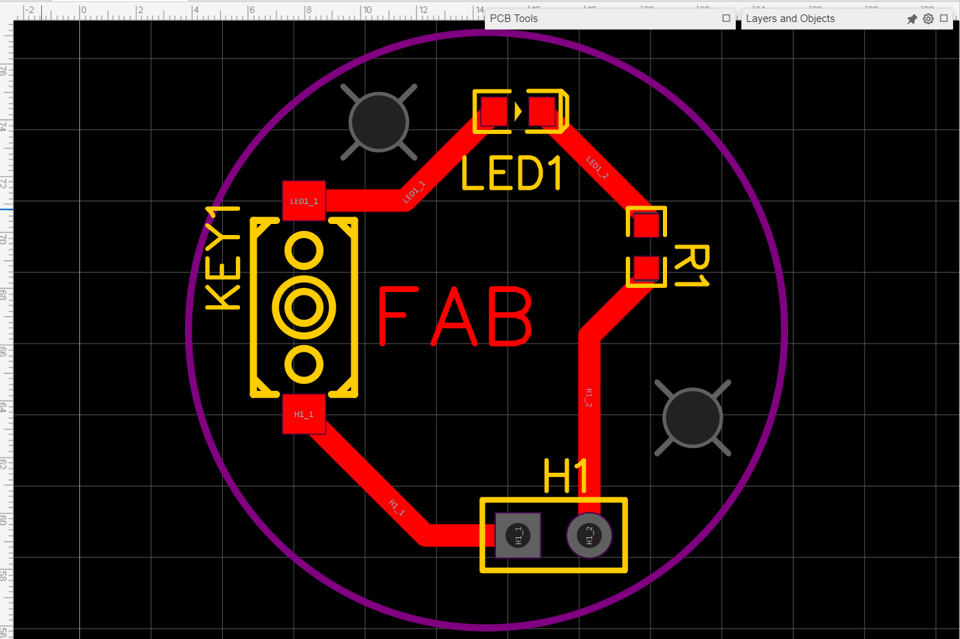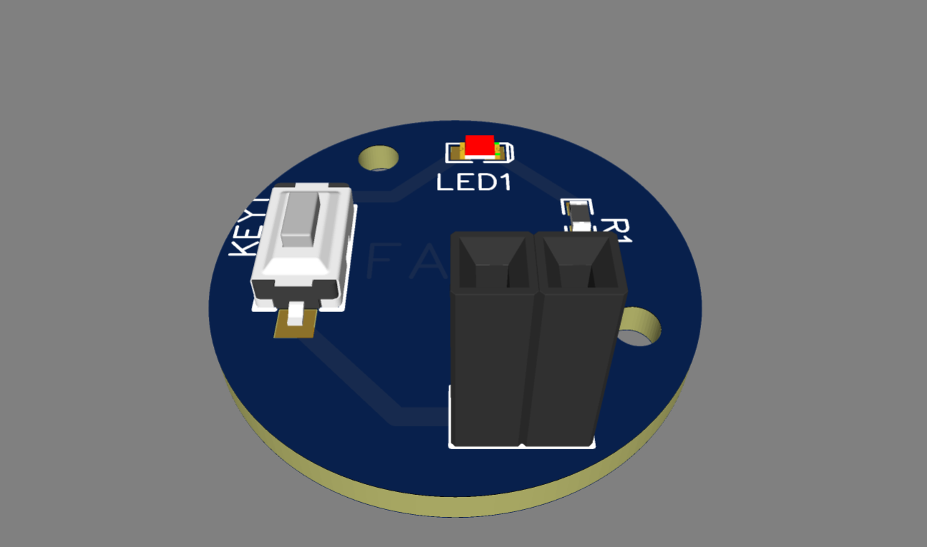

**1.SIMULATION OF HALF ADDER:**

**CIRCUIT OVERVIEW:**

A half adder is a simple digital circuit used in arithmetic operations to add two single-bit binary numbers. It produces two outputs: a sum and a carry. The sum represents the direct addition result, while the carry indicates if there was an overflow to the next higher bit.

**COMPONENTS:**

* **A half adder uses two basic components:**

1. XOR Gate**:**

Produces the sum output.

1. AND Gate**:**

Produces the carry output.

**3.**Power Supply:

Typically, 5V for standard digital logic circuits.

**4**.Resistors:

Current-limiting resistors for LEDs.

**5.**LEDs:

To indicate the sum and carry output

**DIAGRAMS:**

**Circuit schematic in Tinkercad:**

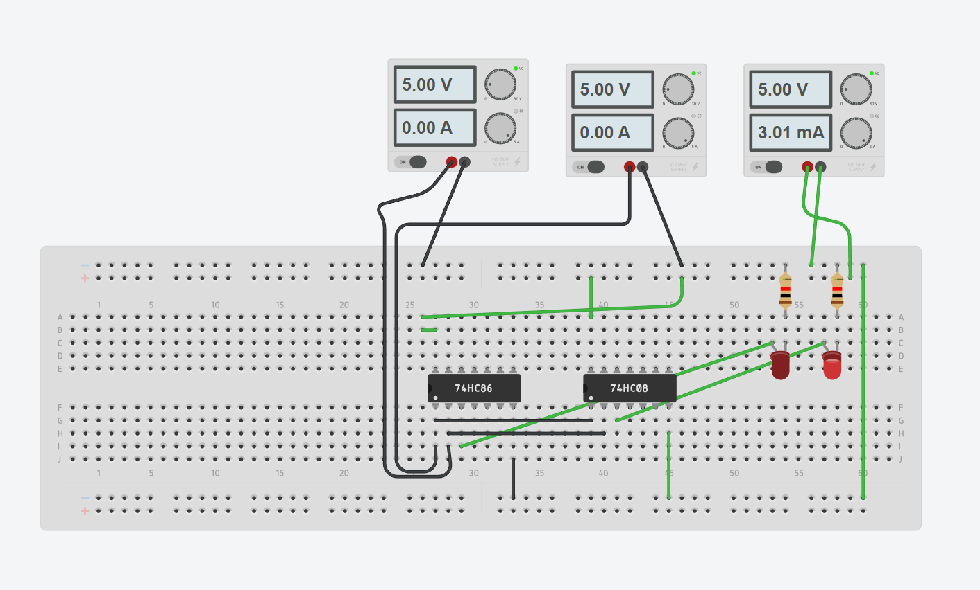

**IN EASYEDA:**

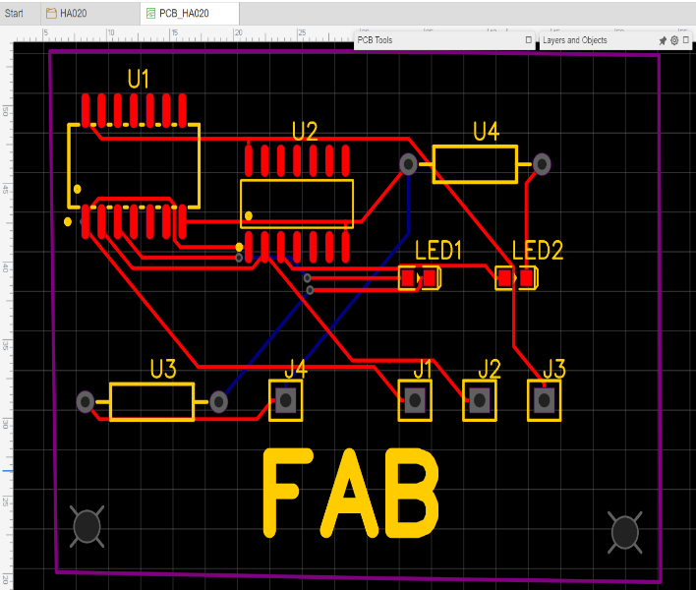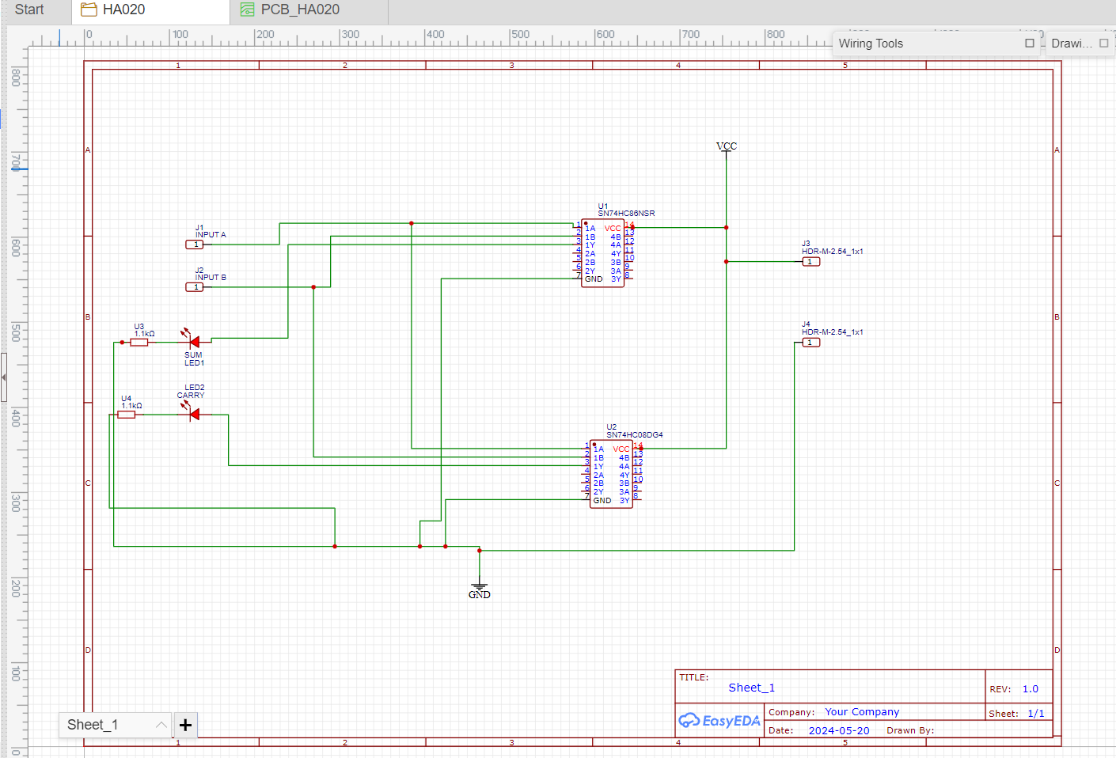

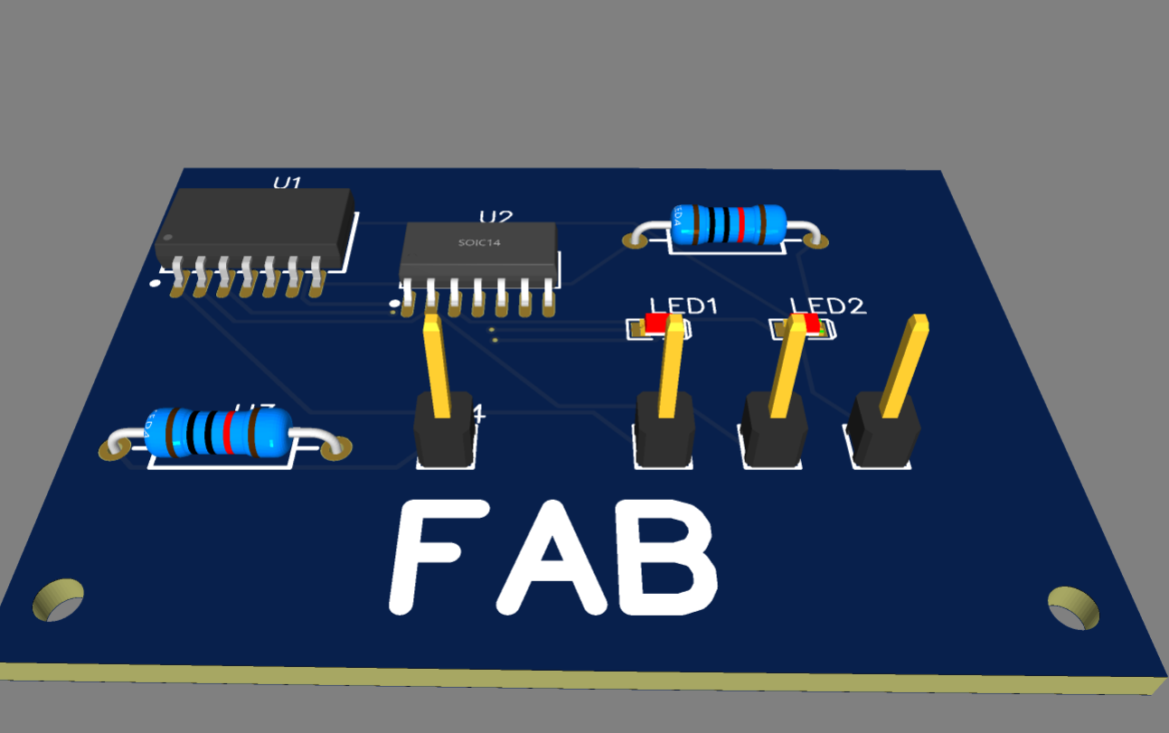

**3.SIMULATION OF 555 TIMER:**

**CIRCUIT OVERVEIW:**

The 555 timer is an integrated circuit used for generating precise time delays and oscillations. It operates in three modes: astable, monostable, and bistable, making it useful in applications like timers, pulse generation, and oscillators. It is widely used in both analog and digital circuits.

**COMPONENTS:**

* 555 Timer IC: The central component used to generate a stable pulse or oscillation.
* Breadboard: For easy assembly and connections of the components.
* Resistors: Two resistors (e.g., 1kΩ and 10kΩ) to set the timing intervals.
* Capacitor: A 10µF capacitor to determine the oscillation frequency.
* LED: To visually indicate the output of the 555 timer.
* Power Supply: A 9V battery to power the circuit.
* Connecting Wires: To connect all components together on the breadboard**.**

**DIAGRAMS:**

**Circuit schematic in Tinkercad:**

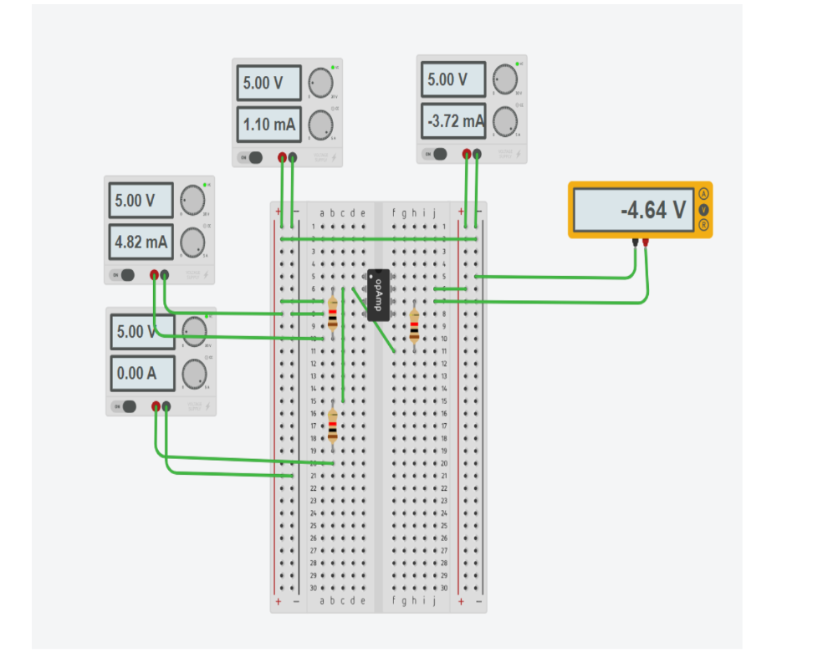

**EASYEDA:**

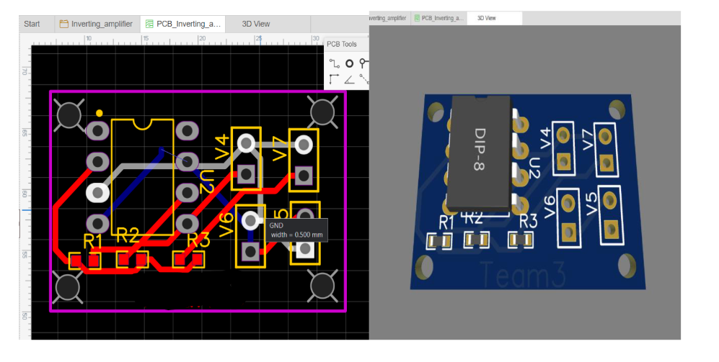

**HARDWARE RESULTS:**

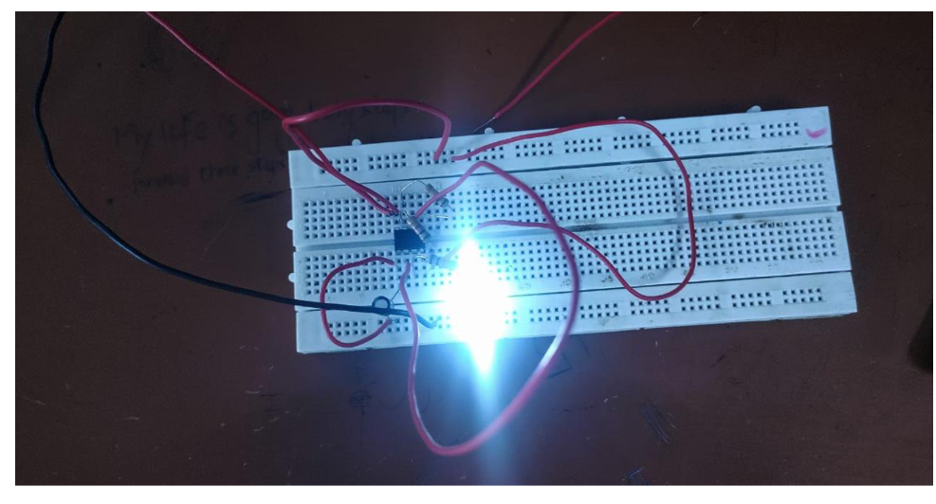

**CONCLUSION:**

In class, we implemented circuits using Tinkercad and EasyEDA: a 555 timer to blink an LED, a half adder for binary addition, and a basic LED on/off switch. These projects enhanced our understanding of timing, digital arithmetic, and basic circuit components, providing hands-on experience in electronics.